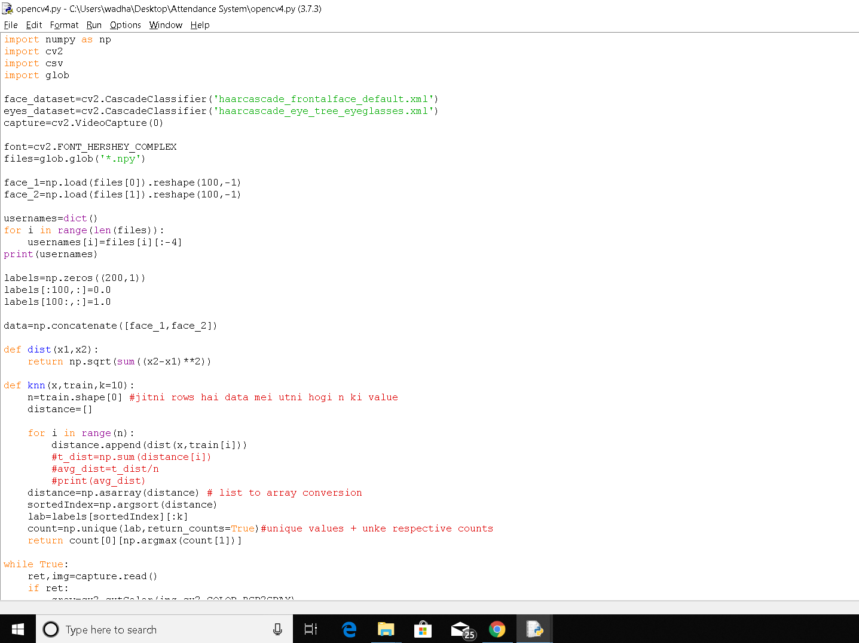

Fig.a

Figure a depicts how the eye and face haar cascades are used to identify the image of the person. In the figure above we import different python libraries including numpy,opencv,csv and glob. We use glob library to load all the files of images having ‘.npy’ extension in a numpy array and then reshape the array according to the number of images. Next we extract the username of the person whose images are stored in the array. We then concatinate the different arrays. The ‘dist’ function is used to calculate the distance of an image from the other. Next we use k nearest neighbours algorithm to identify the nearest five images to the image we have provided through the live web camera and store them in an array. Then we calculate the maximum counts of an image in the array and the image with the maximum counts is declared closest to the provided image.

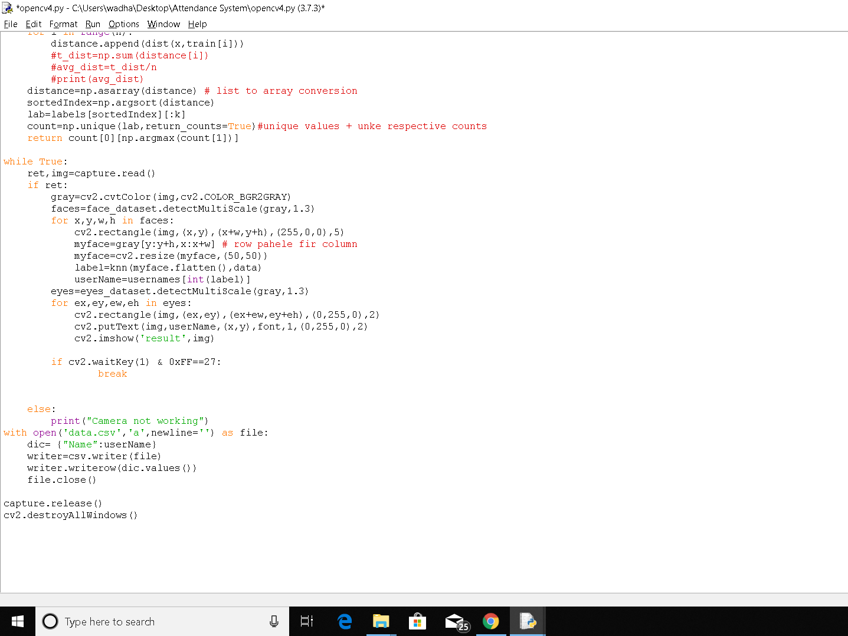

Fig. b

In figure b we use a while loop to capture the video camera and it runs until the loop breaks. The camera captures the image of the person to be identified and a rectangle is drawn around the person’s face and eyes. Through the person’s eyes and face we can identify the person accurately as these features are unique to an individual. Next the k nearest algorithm works and the name of the person appears on the rectangle around their face. The name is then stored in a csv file for the ease of marking attendance.